LEASE MANAGEMENT

**College Name: KALLAM HARANADHAREEDY INSTITUTE OF TECHNOLOGY**

**TEAM ID: LTVIP2025TMID30830**

**TEAM MEMBERS:**

**Team Leader: Harischandra vara prasad velaga Email: [Harivelaga8@gmail.com](mailto:Harivelaga8@gmail.com)**

**Team Member: Areti chandravyas**

**Email: [Chandravyasareti14@gmail.com](mailto:Chandravyasareti14@gmail.com) Team Member: Kodali murali krishna**

**Email: [Kodalimuralikrishna2@gmail.com](mailto:Kodalimuralikrishna2@gmail.com)**

**Team Member: Pamulapati Ravindra**

**[Email:228X1A4559@khitguntur.ac.in](mailto:228X1A4559@khitguntur.ac.in)**

# INTRODUCTION

## Project Overview

The Lease Management System is a Salesforce-based application designed to streamline the processes associated with leasing real estate properties. It handles tenant management, lease contracts, payments, and communication with automation features such as flows, approval processes, and email alerts.

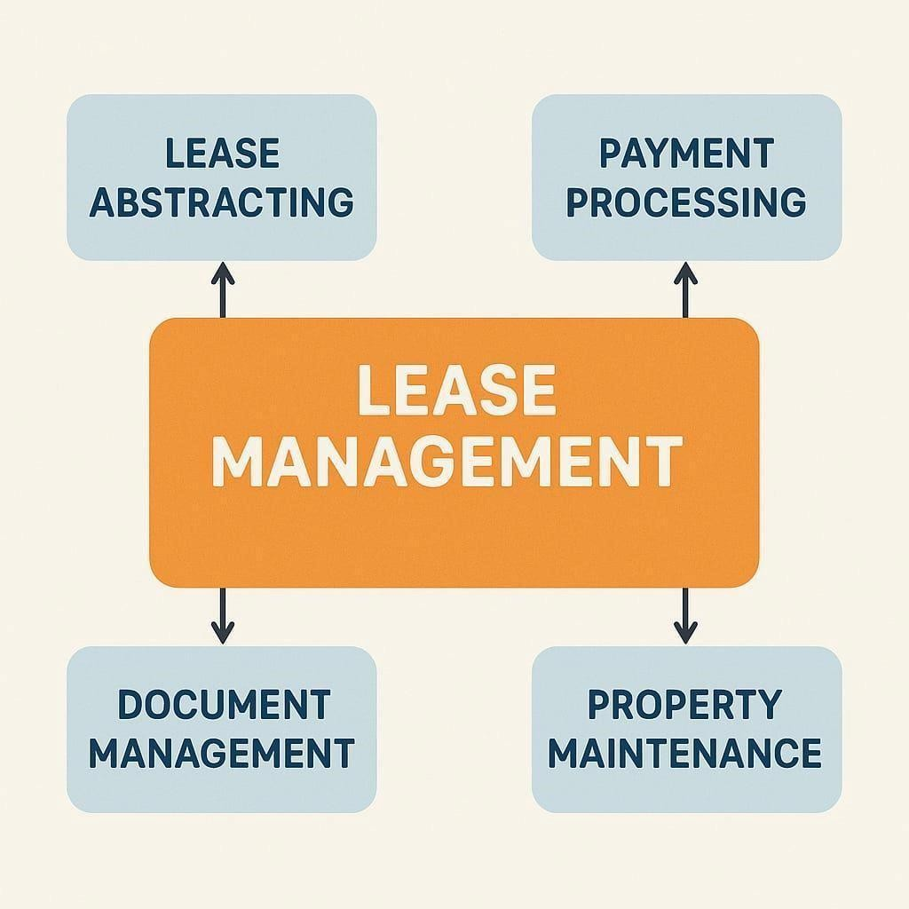

## Purpose

The main objective of the project is to enable organizations to efficiently manage properties, tenants, and lease-related activities. It reduces manual intervention, improves accuracy, and ensures better compliance and communication.

# IDEATION PHASE

## Problem Statement

Managing lease information manually can lead to errors, missed payments, and communication delays. There is a need for a centralized, automated system to maintain lease records, track payments, and manage tenants efficiently.

## Empathy Map Canvas

* + - **Think & Feel**: Needs confidence in lease management.
    - **Hear**: Concerns from tenants about payment reminders.
    - **See**: Missed lease renewals and tracking issues.
    - **Say & Do**: Wants a smooth system to manage leases and communications.
    - **Pain**: Manual tracking, miscommunication.
    - **Gain**: Streamlined processes, reduced errors.

## Brainstorming

Ideas included automated alerts, integrated payment tracking, custom objects for modular data, and use of approval processes to manage tenant transitions.

# REQUIREMENT ANALYSIS

## Customer Journey Map

Tenants interact with the system by applying for leases, receiving emails for payment and status updates, and submitting leave requests. Admins handle object creation, approval processes, and maintain oversight through dashboards and flows.

## Solution Requirement

* + - Salesforce platform
    - Custom Objects: Property, Tenant, Lease, Payment
    - Email Templates
    - Apex Triggers & Classes
    - Flow automation
    - Approval Processes

## Data Flow Diagram

Tenant → Lease → Payment

Admin approval → Triggered Emails

↳↳ Scheduled class → Monthly Reminders

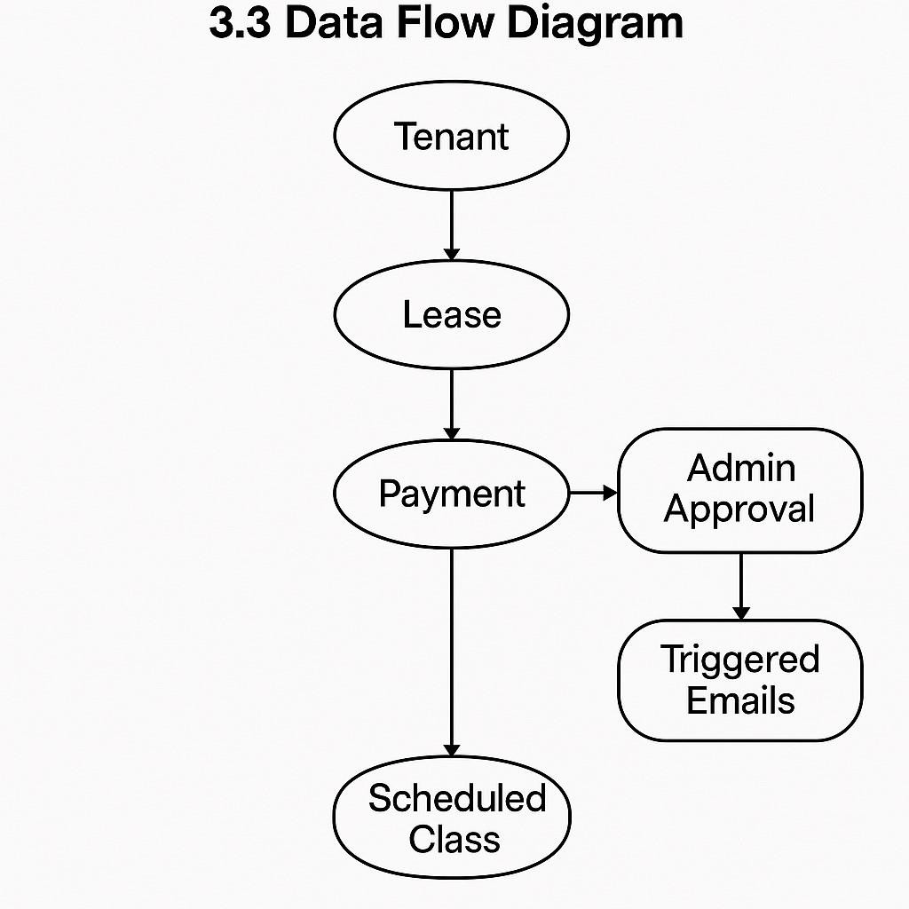

## Technology Stack

* + - **Platform**: Salesforce Lightning
    - **Language**: Apex
    - **Automation**: Salesforce Flow
    - **Database**: Salesforce Custom Objects
    - **Communication**: Classic Email Templates

# PROJECT DESIGN

## Problem-Solution Fit

The system solves lease tracking, tenant management, and payment notification problems using Salesforce’s automation and customization features.

## Proposed Solution

Create custom Salesforce objects and implement workflows, email templates, and Apex triggers to automate all critical lease management functions.

## Solution Architecture

* + - **Frontend**: Salesforce UI via Lightning Apps
    - **Backend**: Custom Objects and Apex
    - **Automation**: Flows, Validation Rules, Scheduled Jobs
    - **Integration**: Email alerts via templates

# PROJECT PLANNING & SCHEDULING

## Project Planning

* + - Week 1: Object and Field Creation
    - Week 2: Tab and App Setup
    - Week 3: Flows and Email Templates
    - Week 4: Apex Triggers & Approval Process
    - Week 5: Testing & Validation

# DEVELOPMENT PHASE

### Creating Developer Account:

By using this URL **- <https://www.salesforce.com/form/developer-signup/?d=pb>**

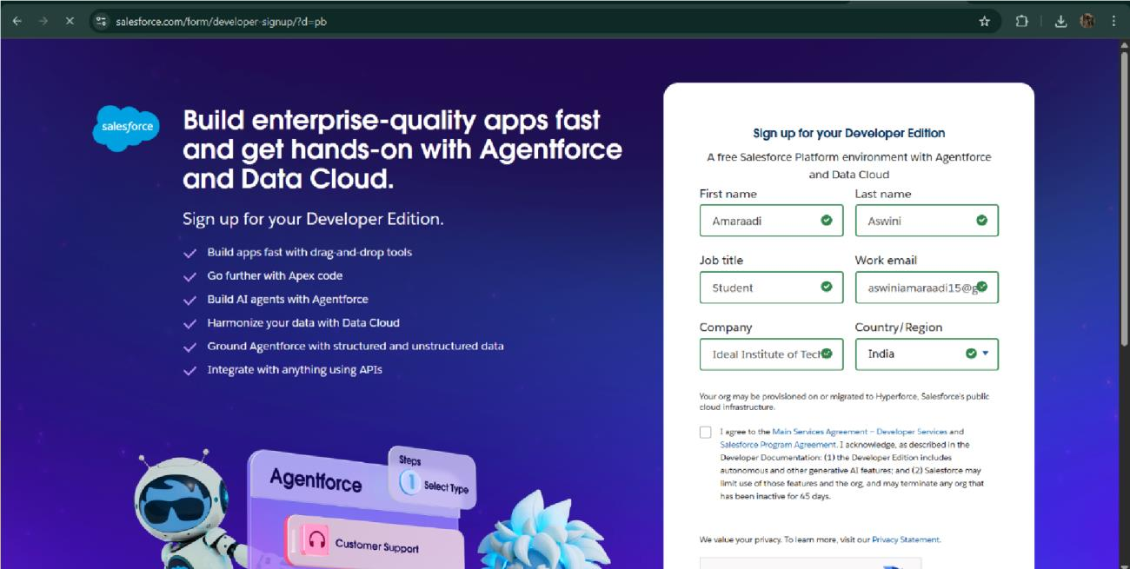

* Created objects: Property, Tenant, Lease, Payment

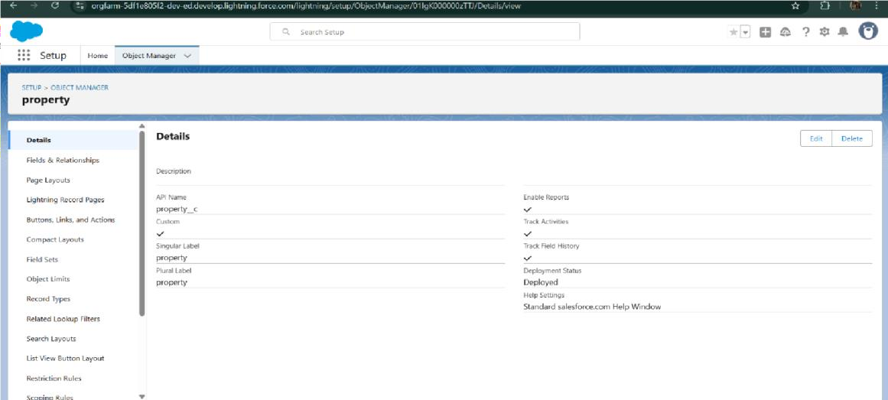

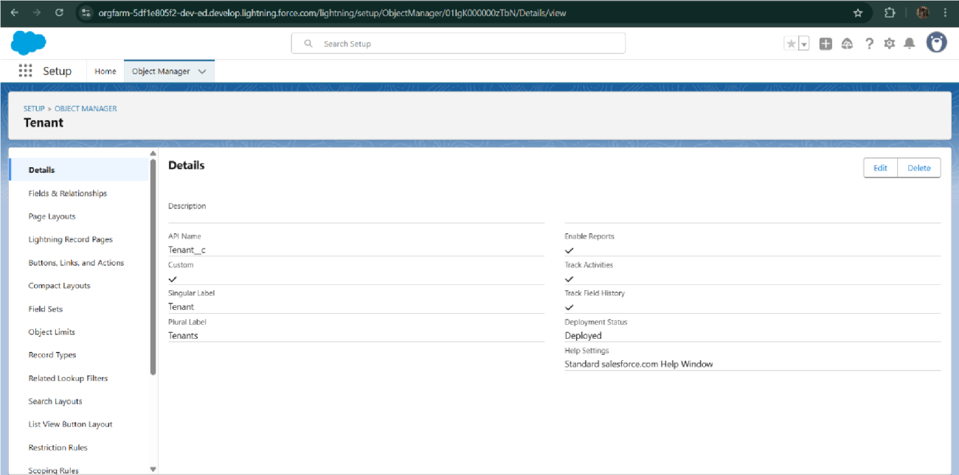

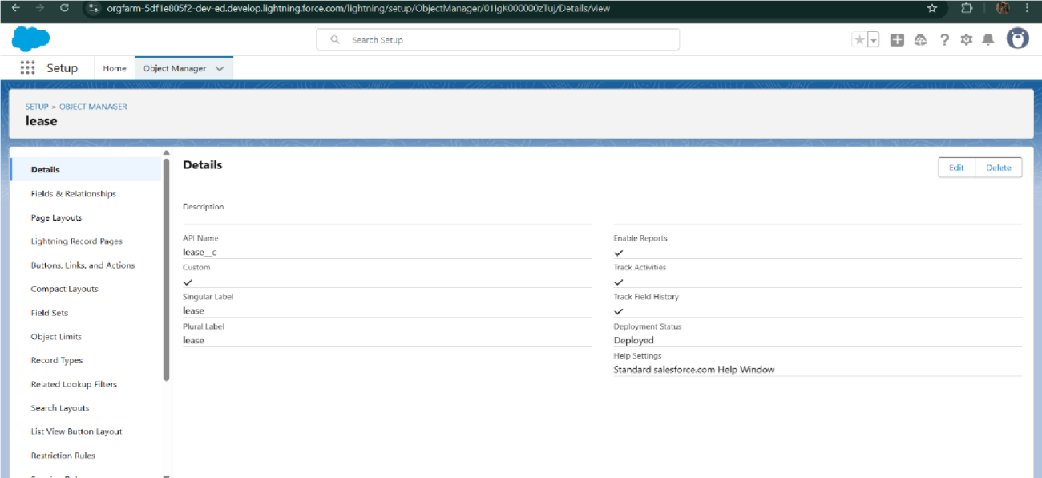

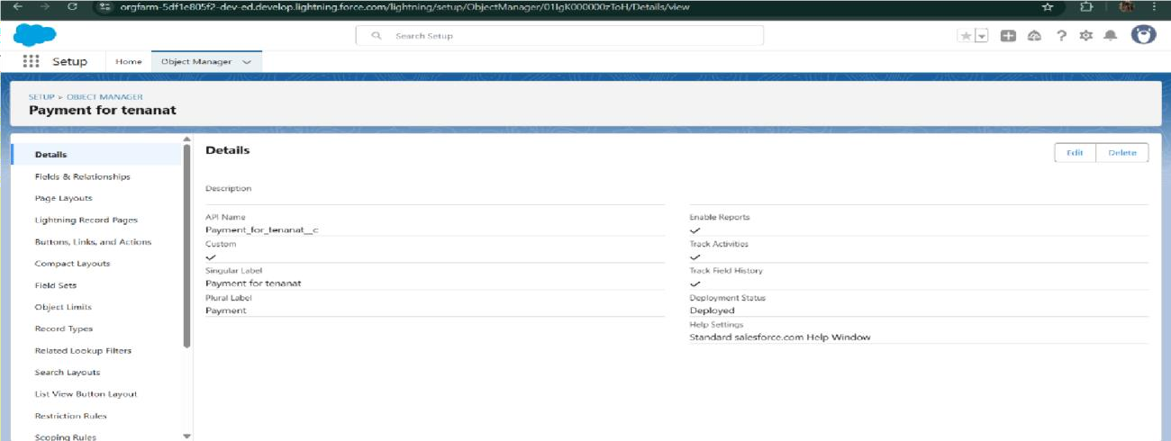

* Configured fields and relationships

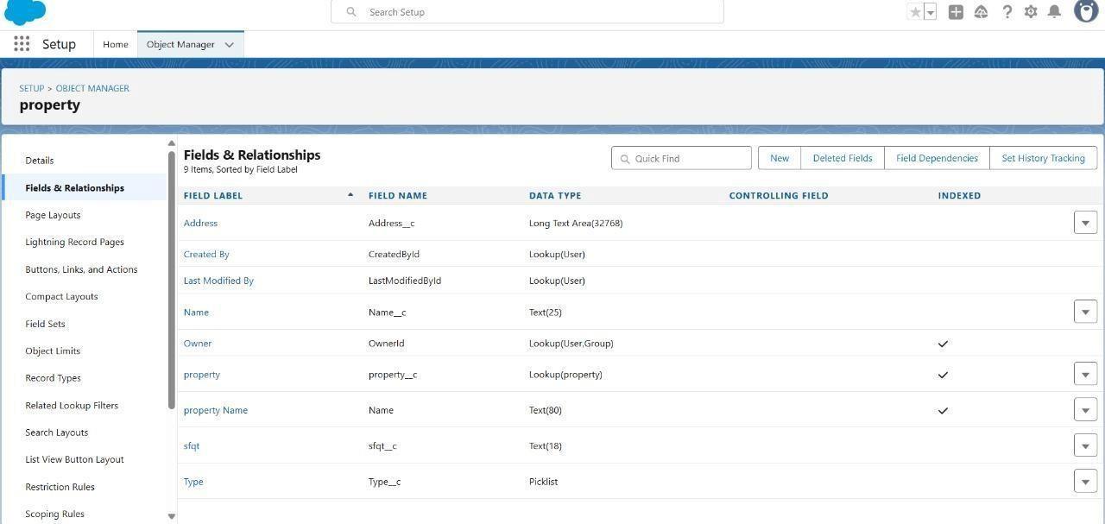

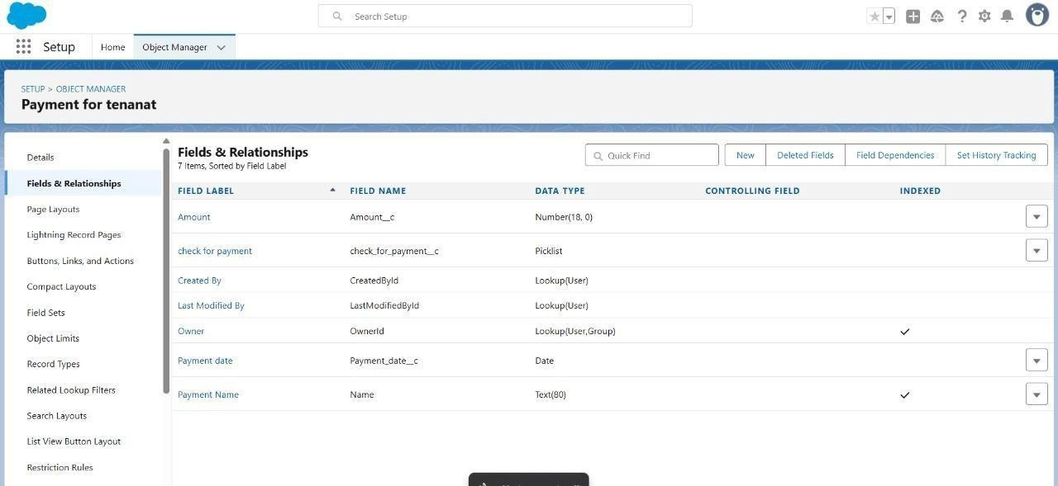

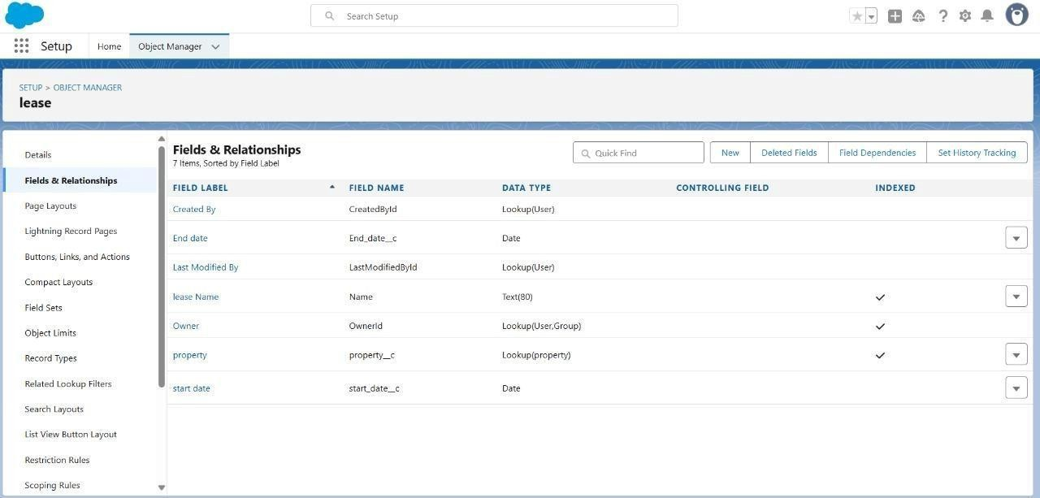

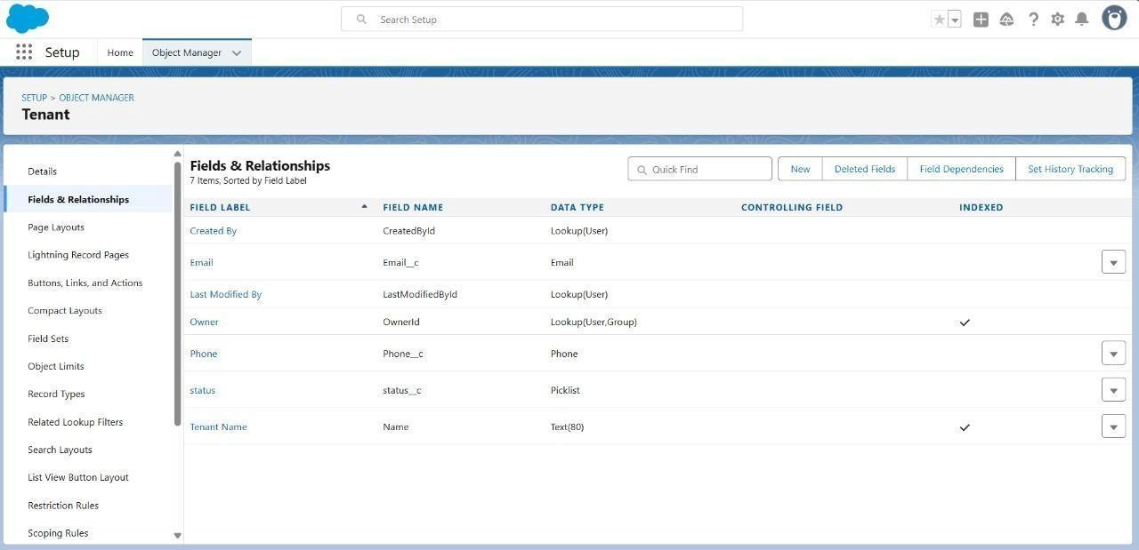

* Developed Lightning App with relevant tabs

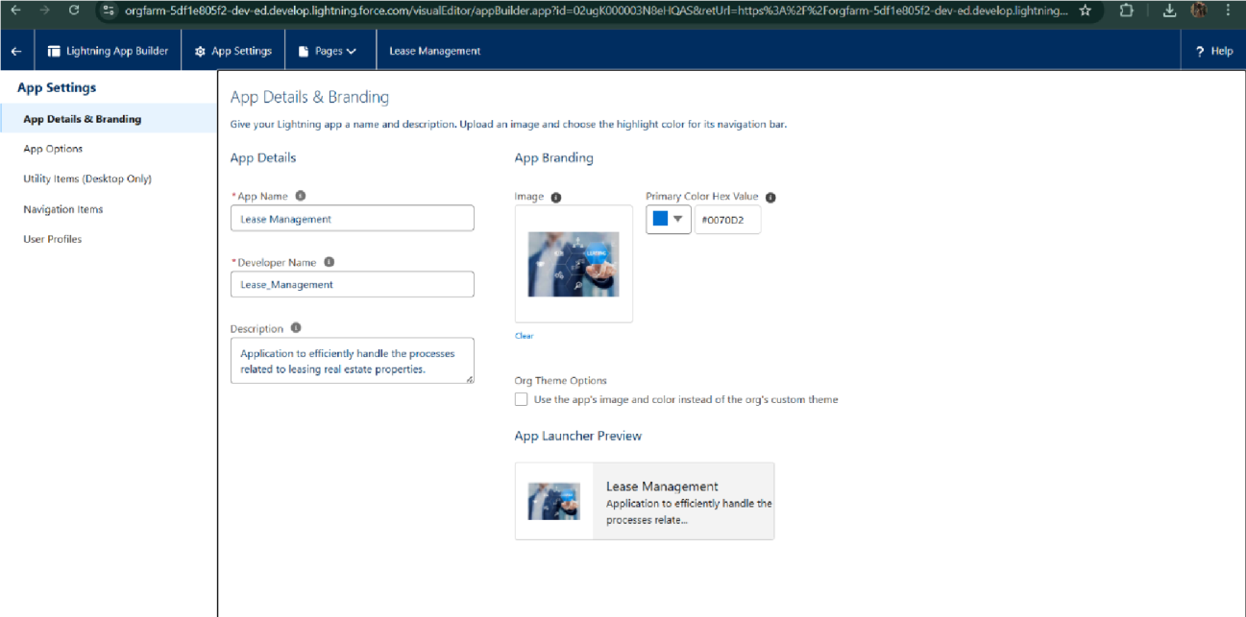

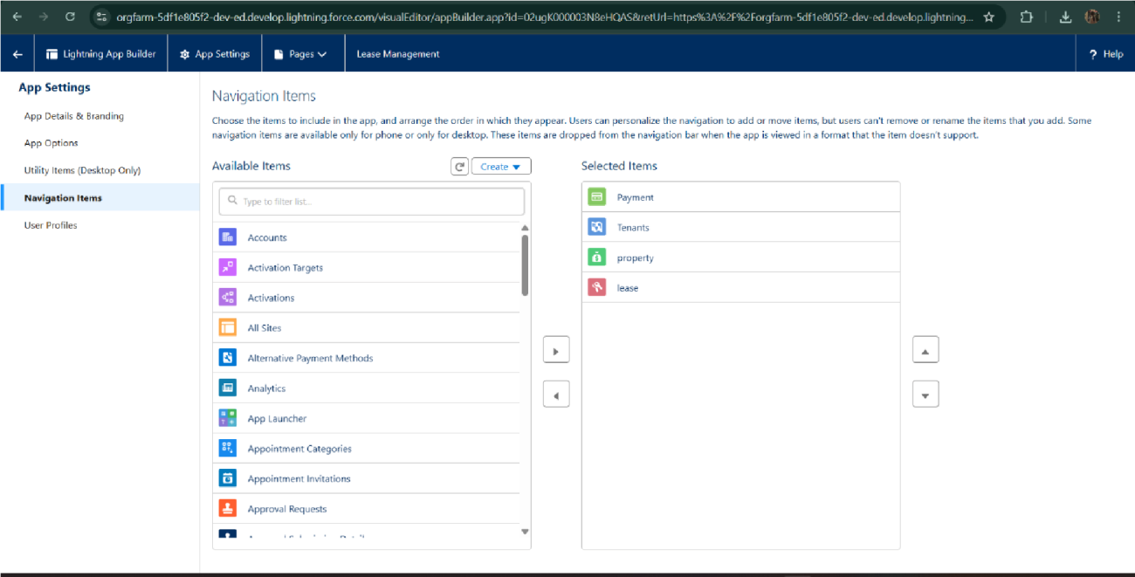

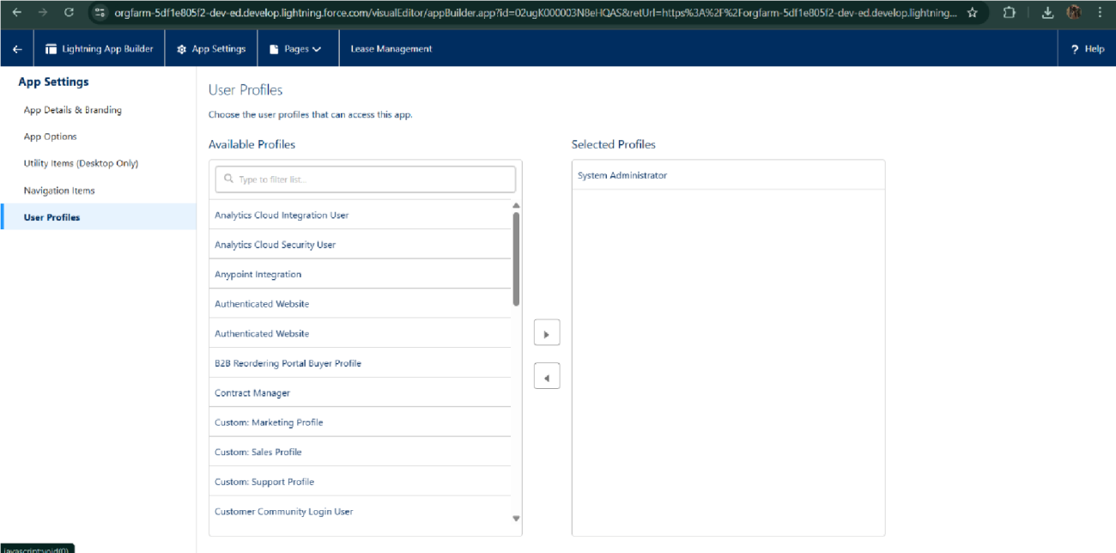

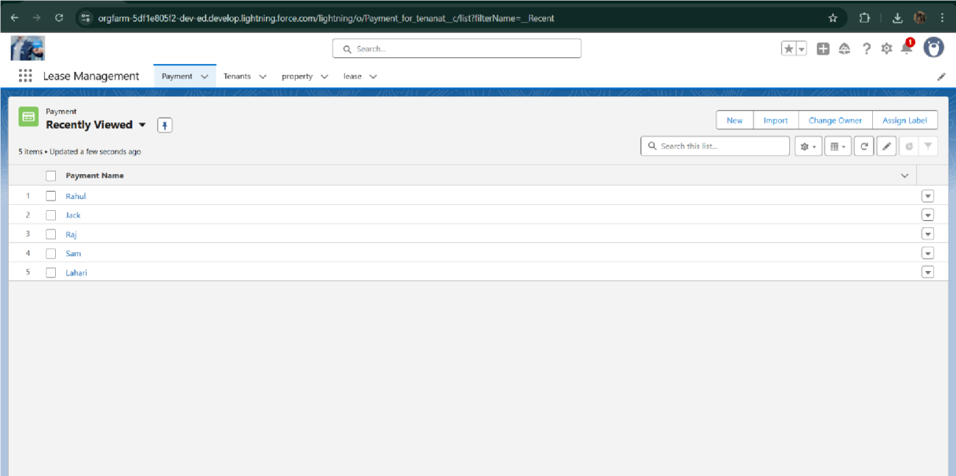

* Implemented Flows for monthly rent and payment success

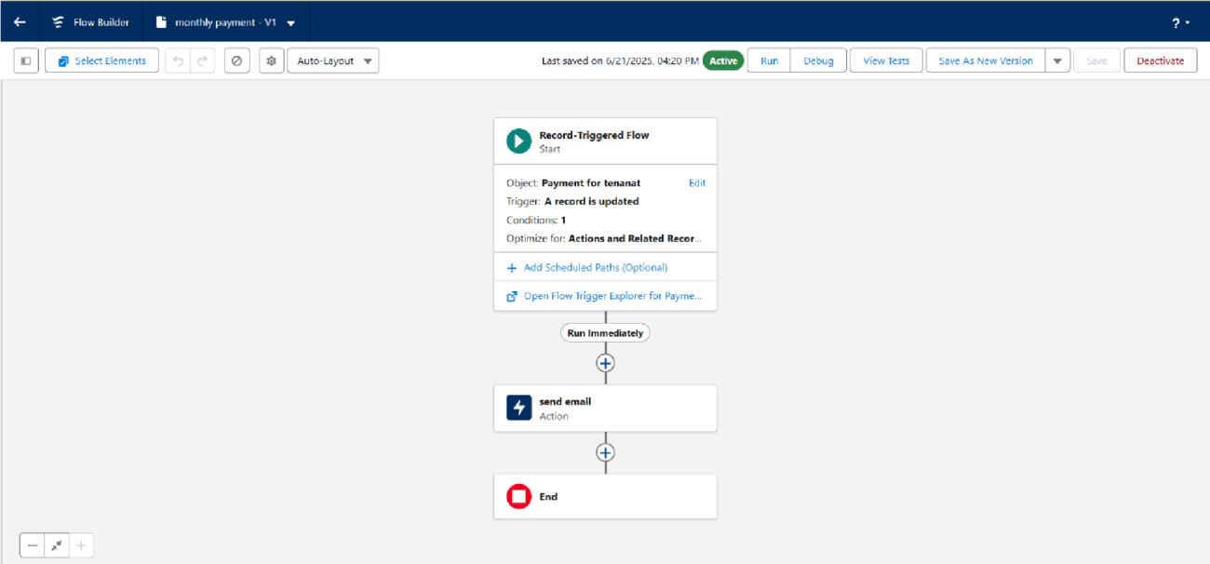

* To create a validation rule to a Lease Object

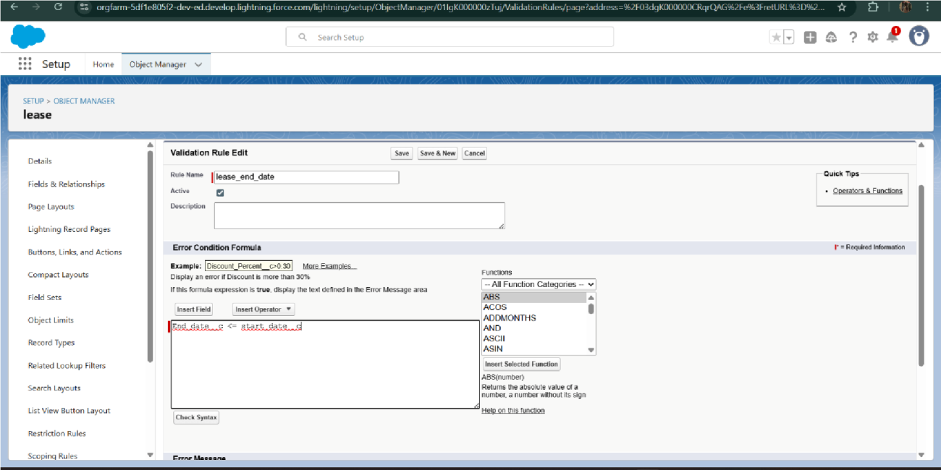

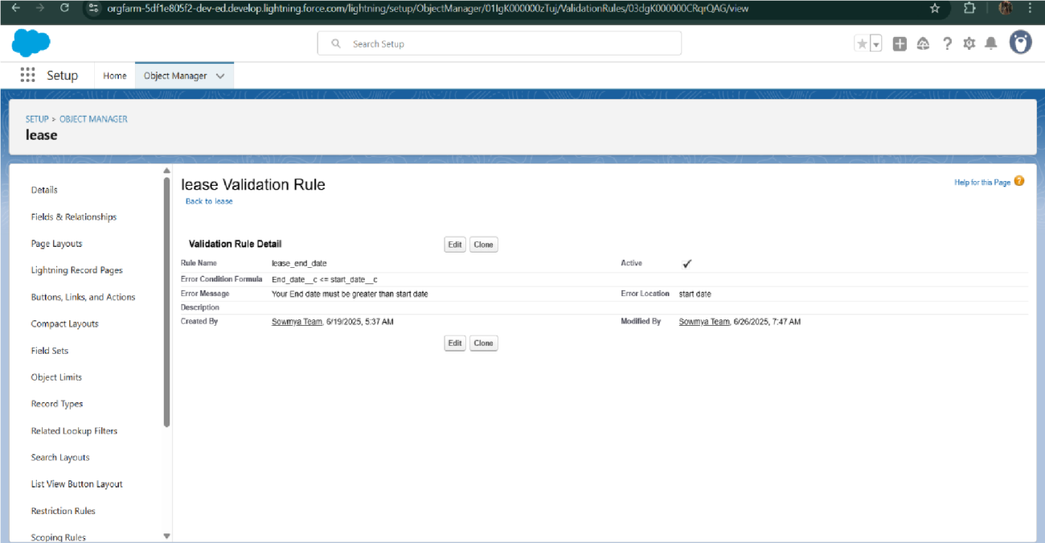

* Added Apex trigger to restrict multiple tenants per property

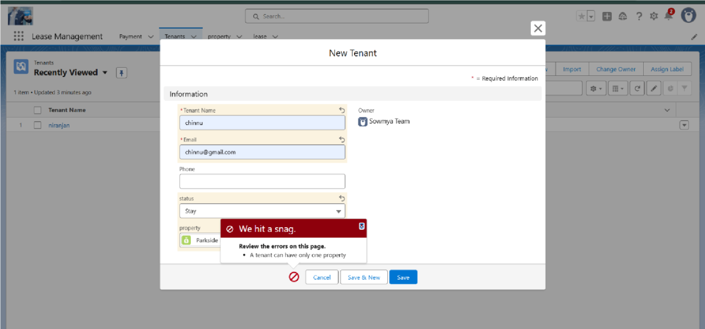

* Scheduled monthly reminder emails using Apex class

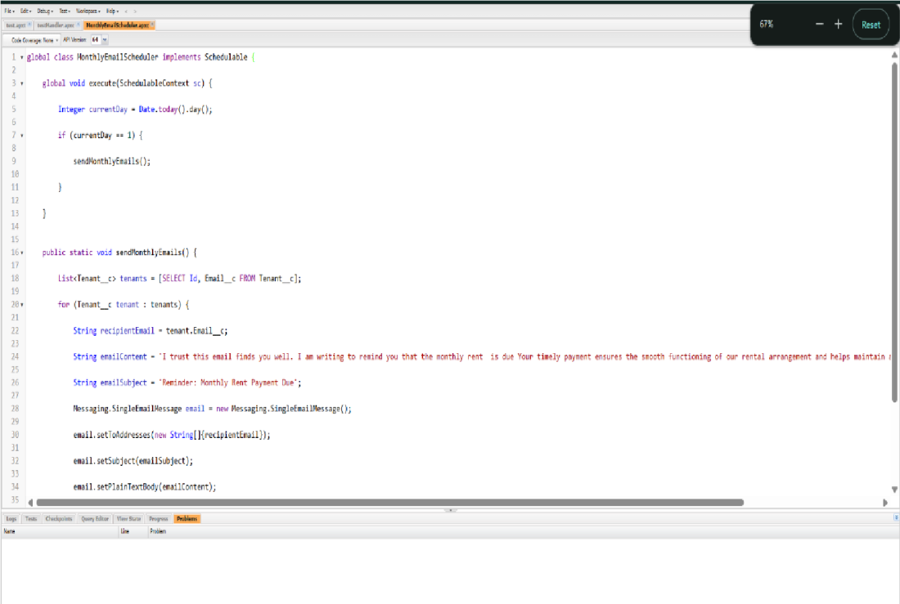

* Built and tested email templates for leave request, approval, rejection, payment, and reminders

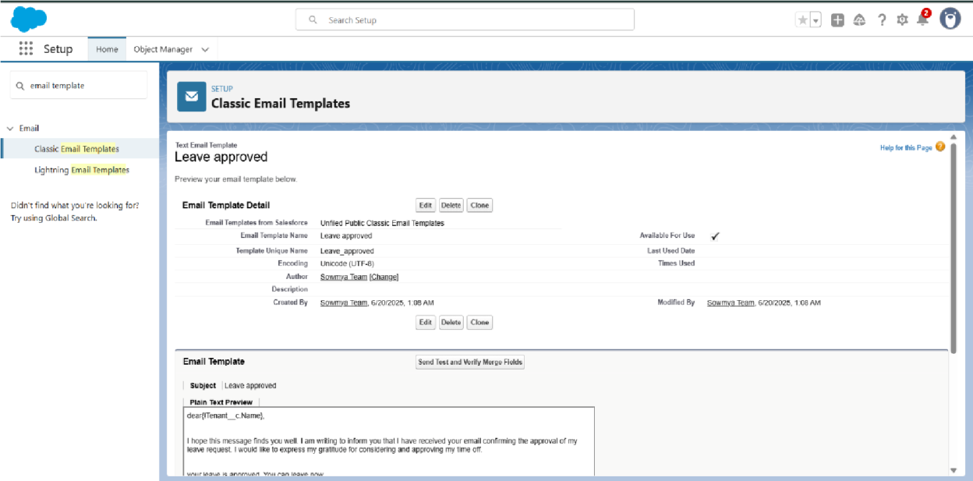

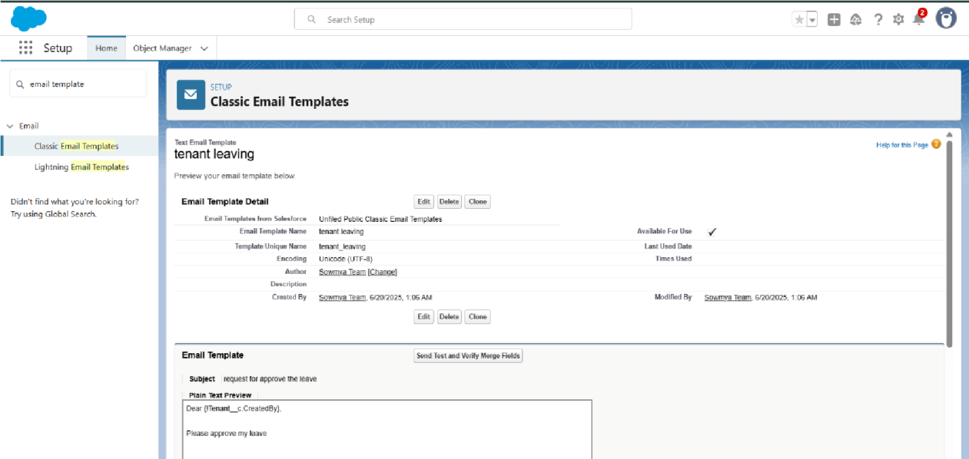

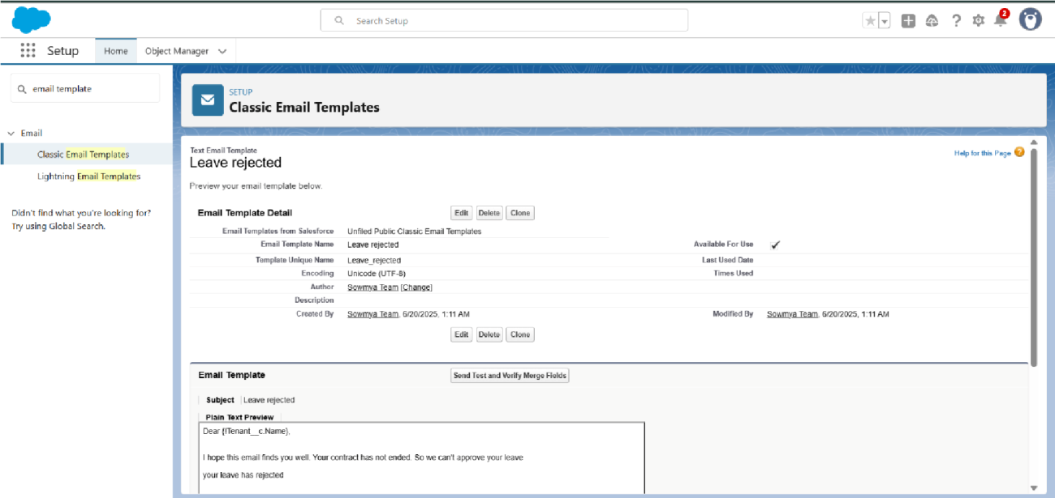

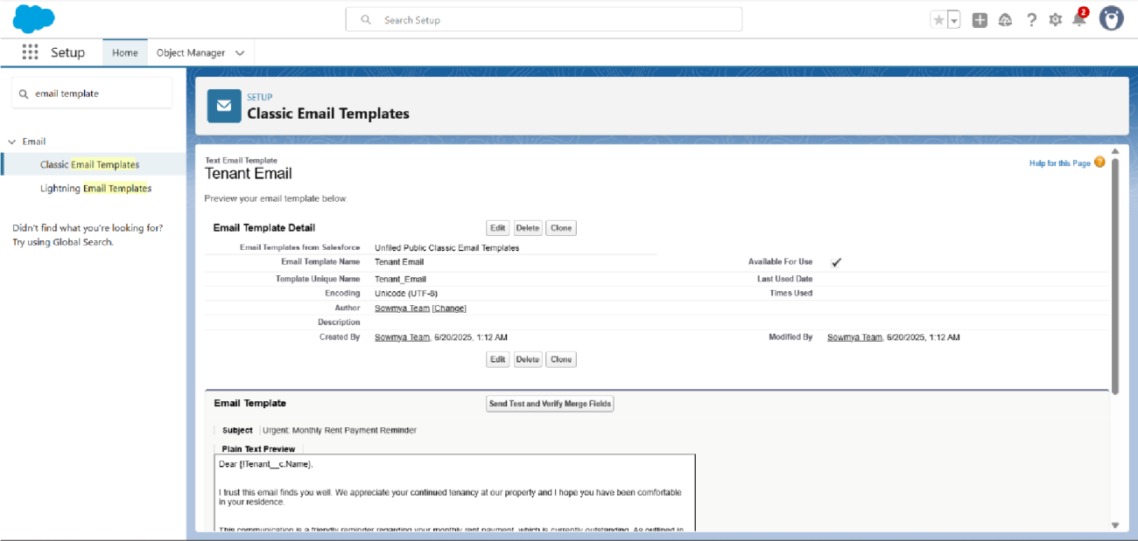

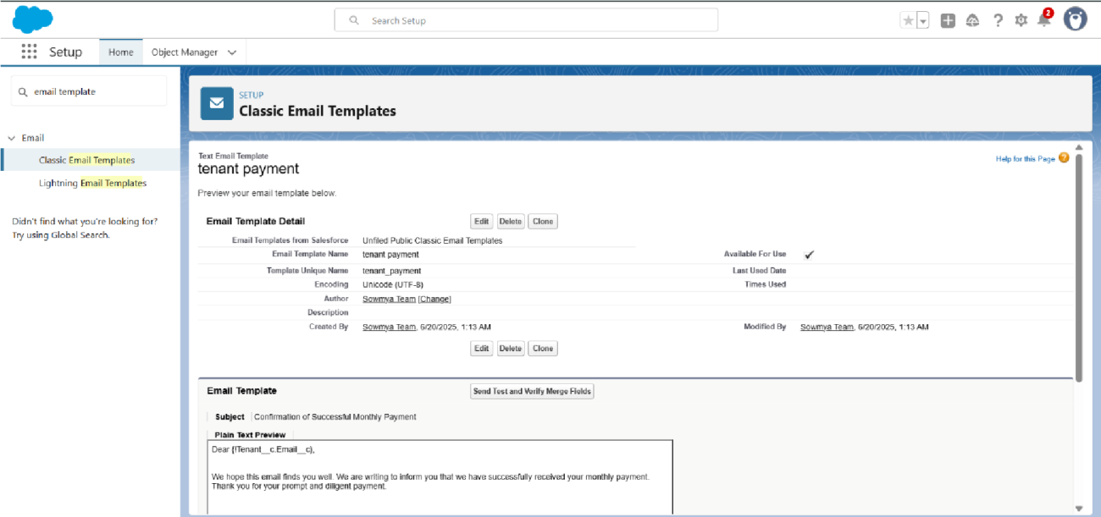

* Approval Process creation

For Tenant Leaving:

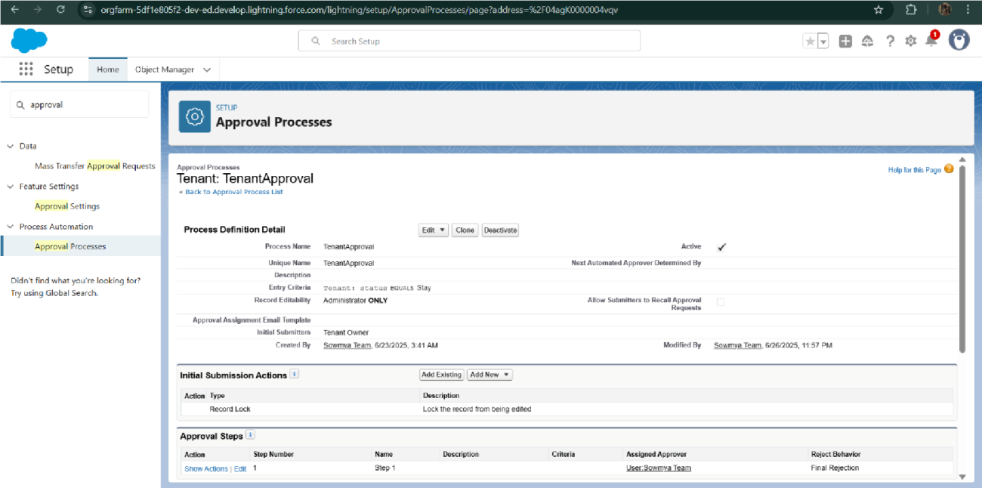

For Check for Vacant:

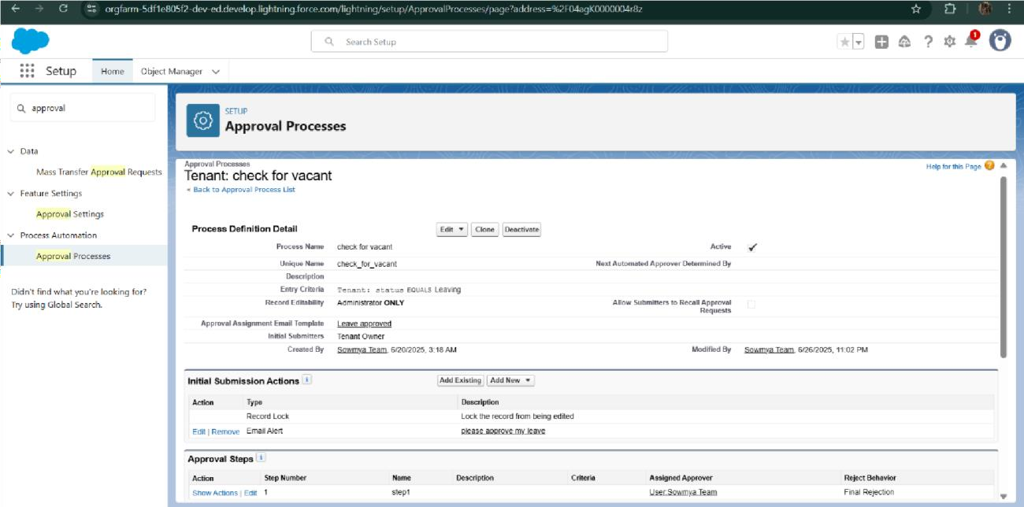

* Apex Trigger

Create an Apex Trigger

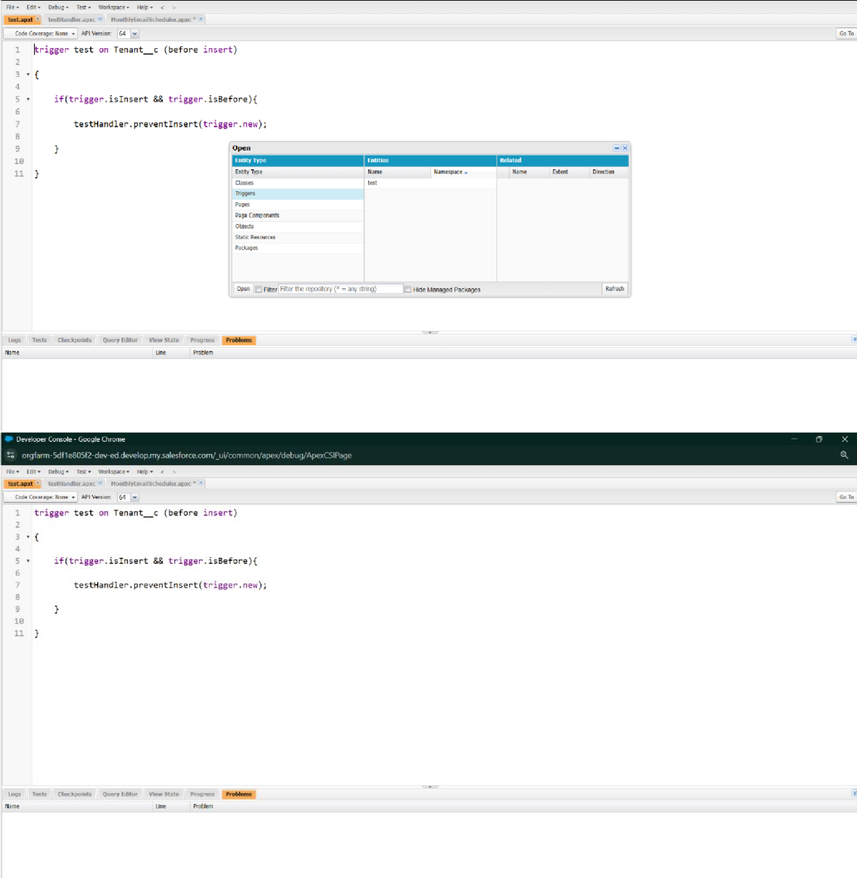

Create an Apex Handler class

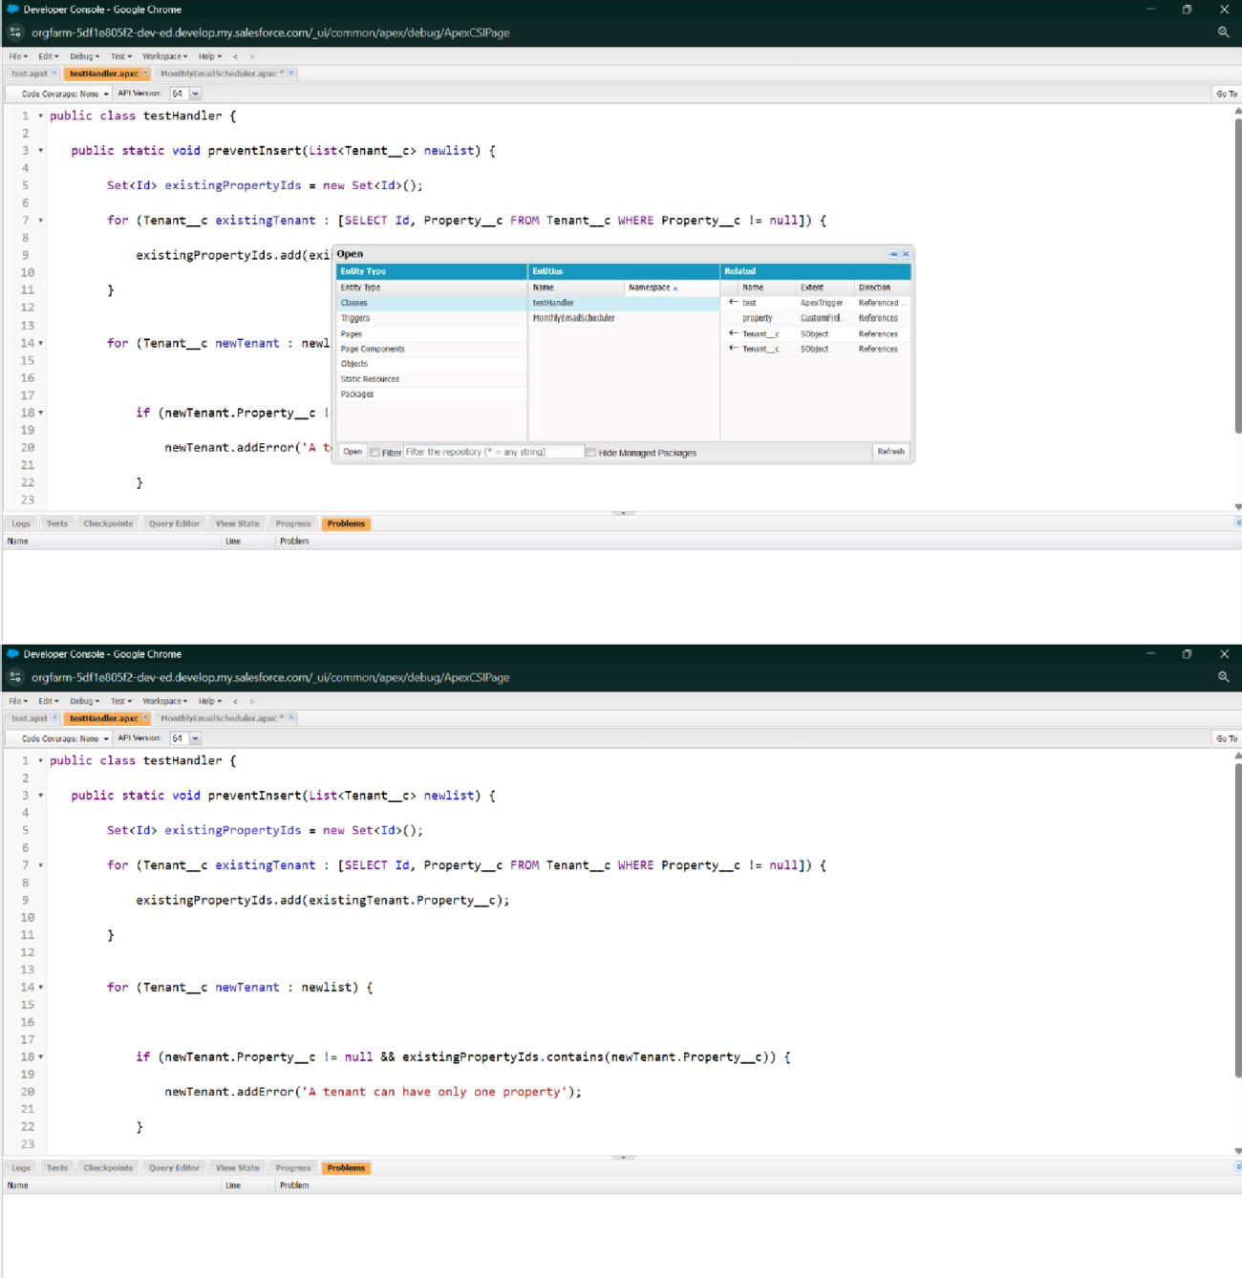

* FLOWS

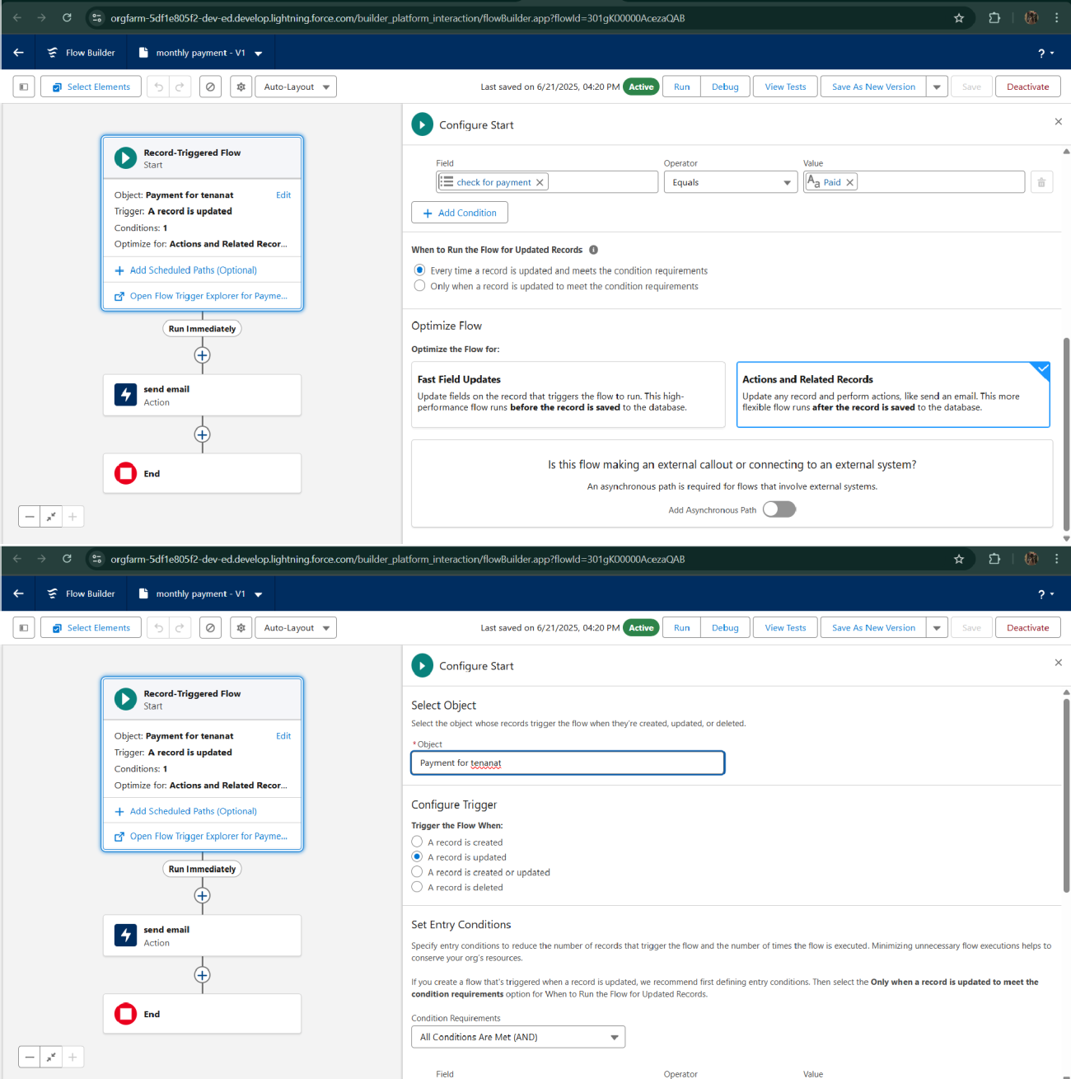

* Schedule class:

Create an Apex Class

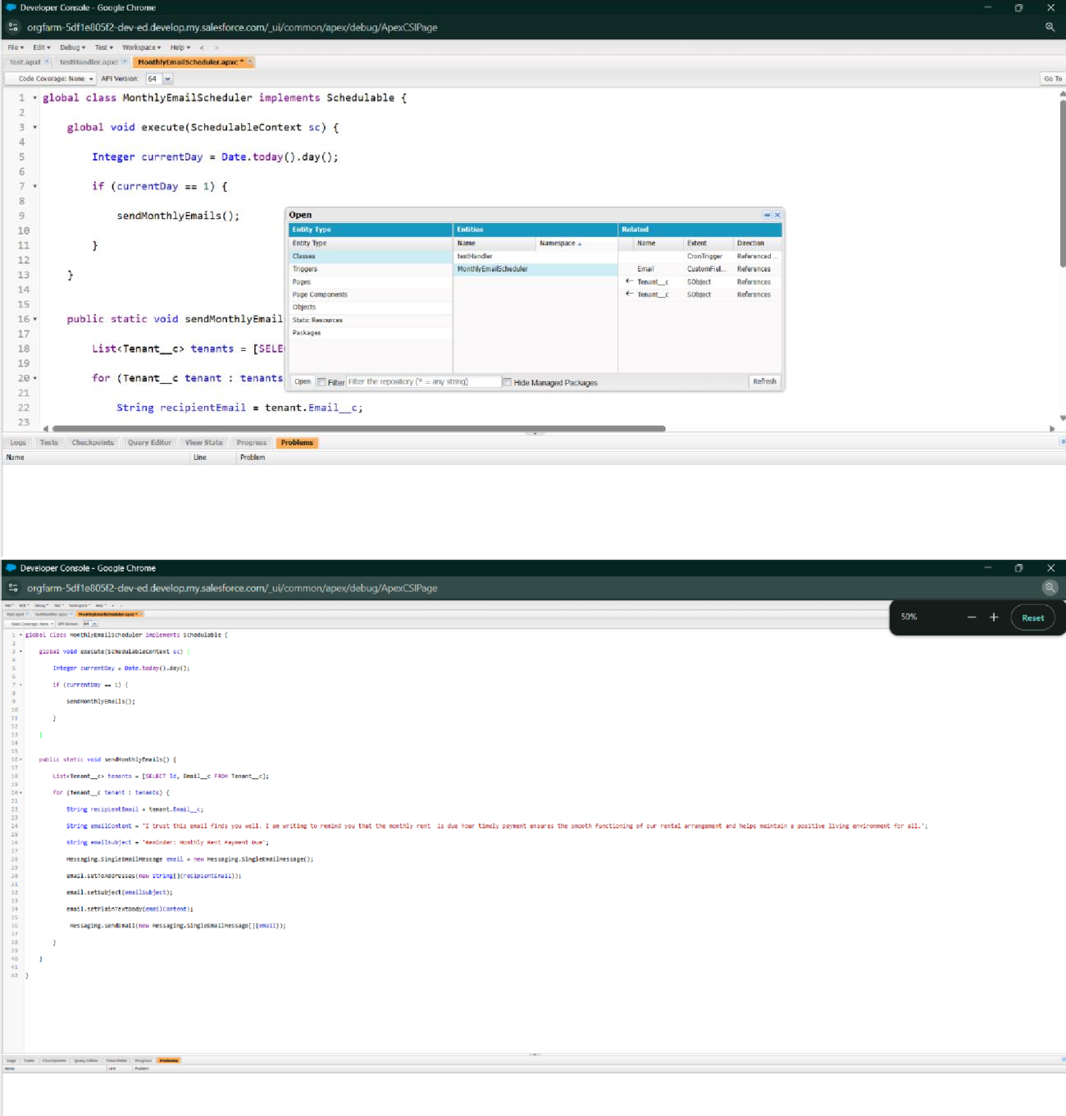

Schedule Apex class

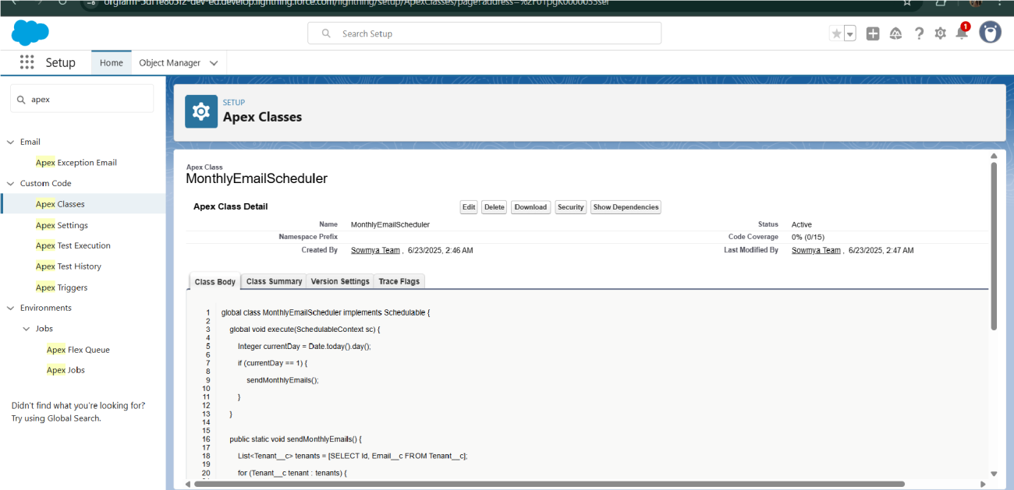

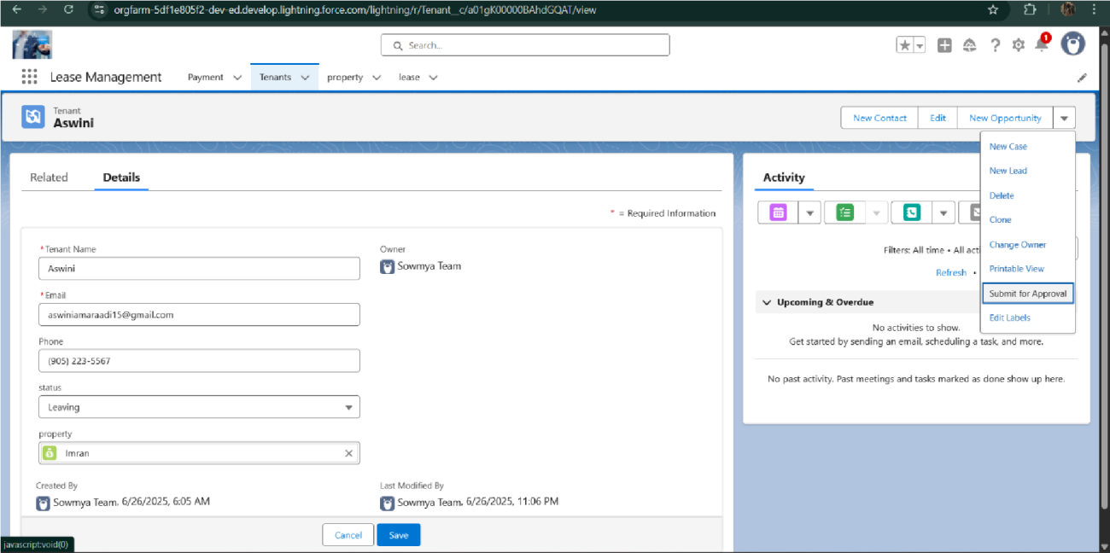

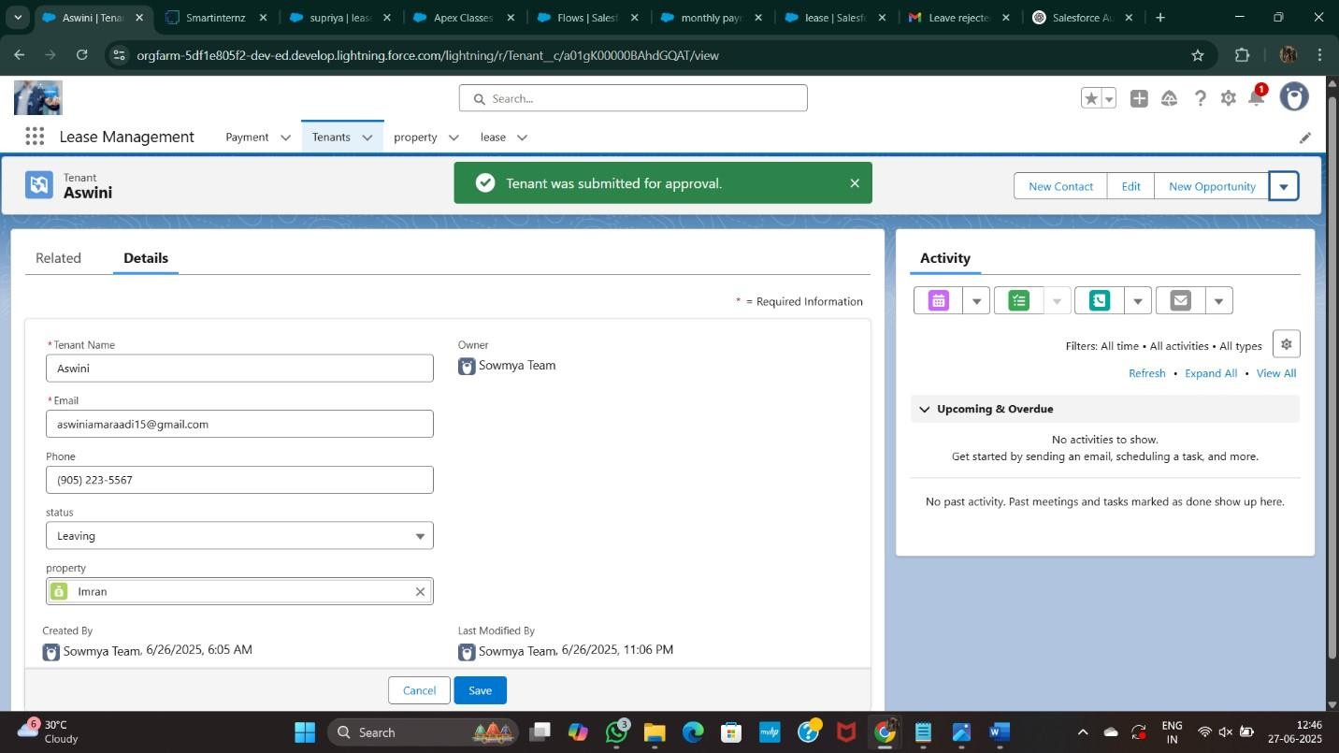

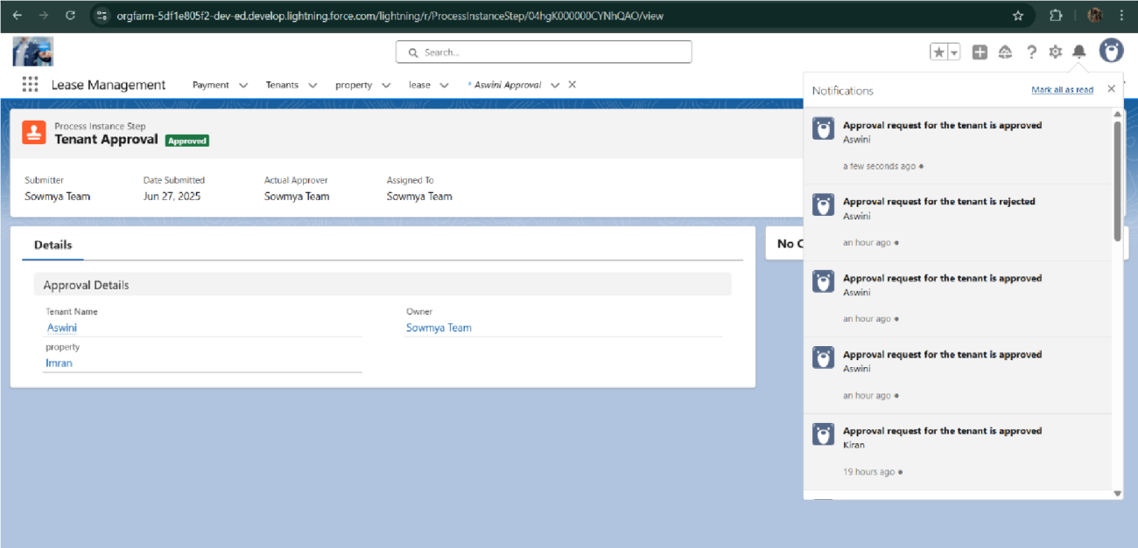

# FUNCTIONAL AND PERFORMANCE TESTING

## Performance Testing

* + - 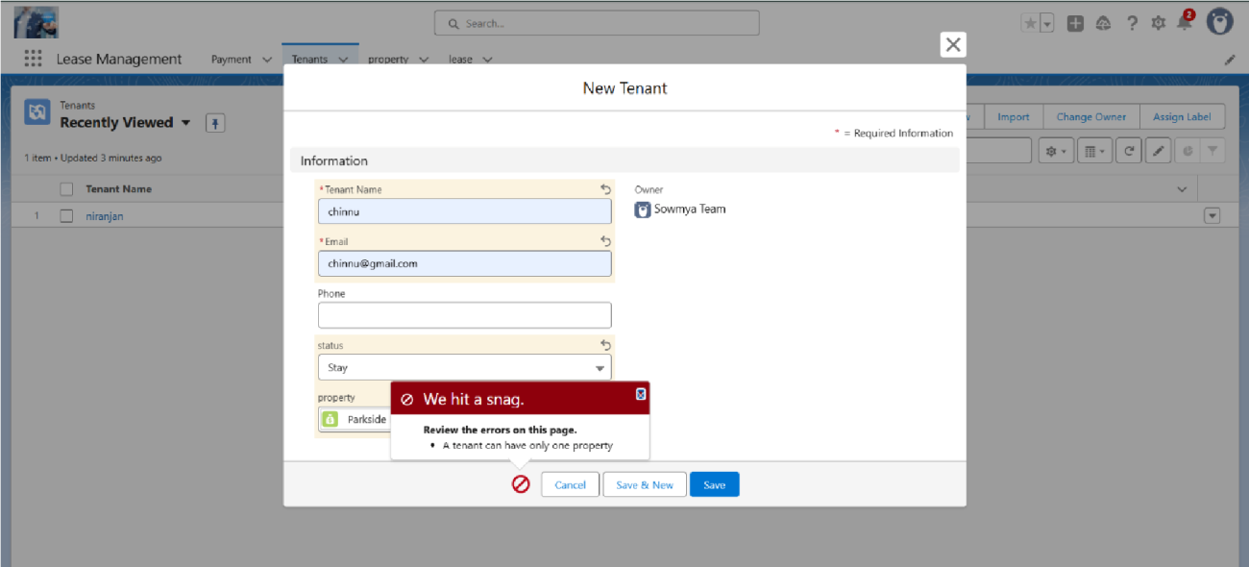Trigger validation by entering duplicate tenant-property records
    - Validation Rule checking

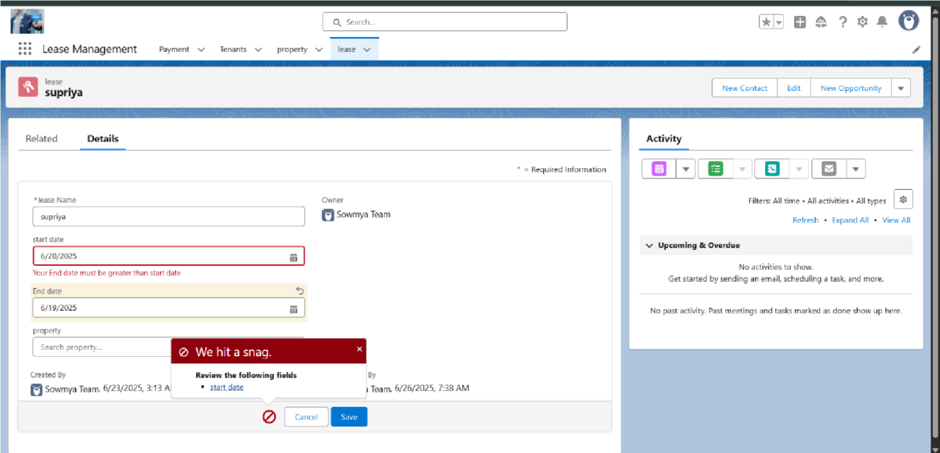

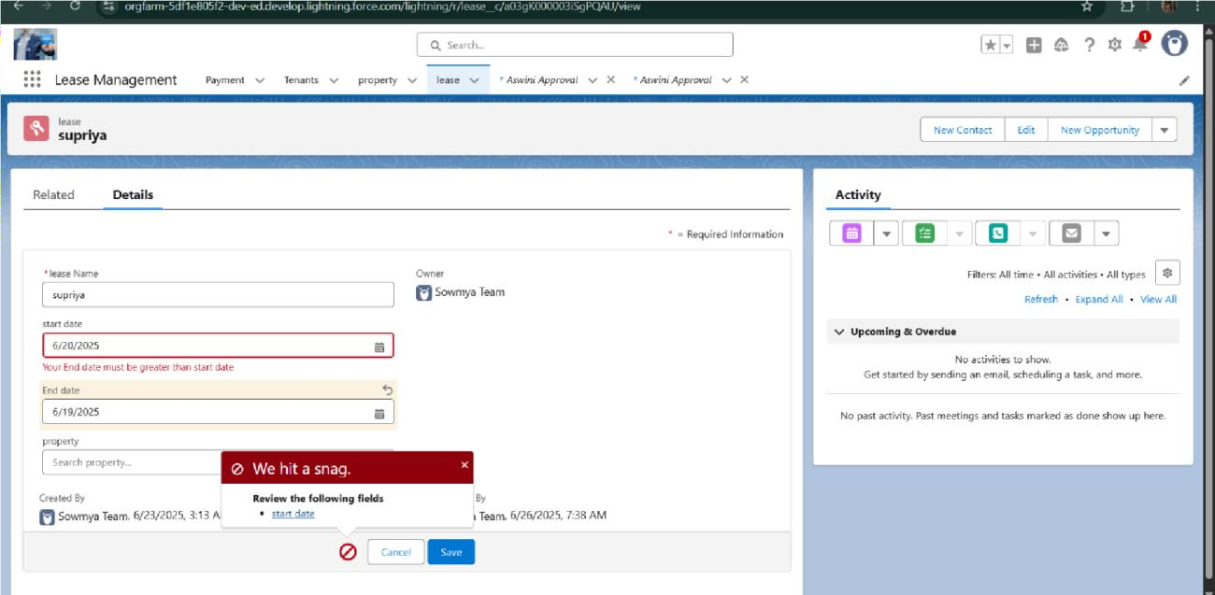

* + - Test flows on payment update

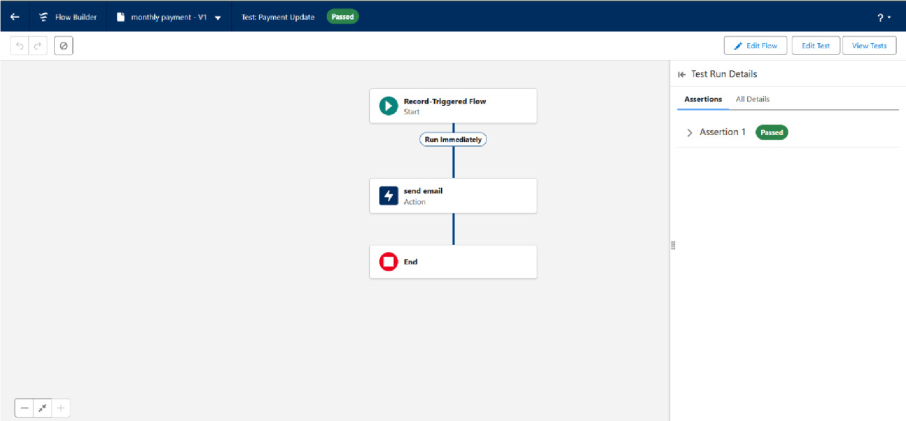

* + - Approval process validated through email alerts and status updates

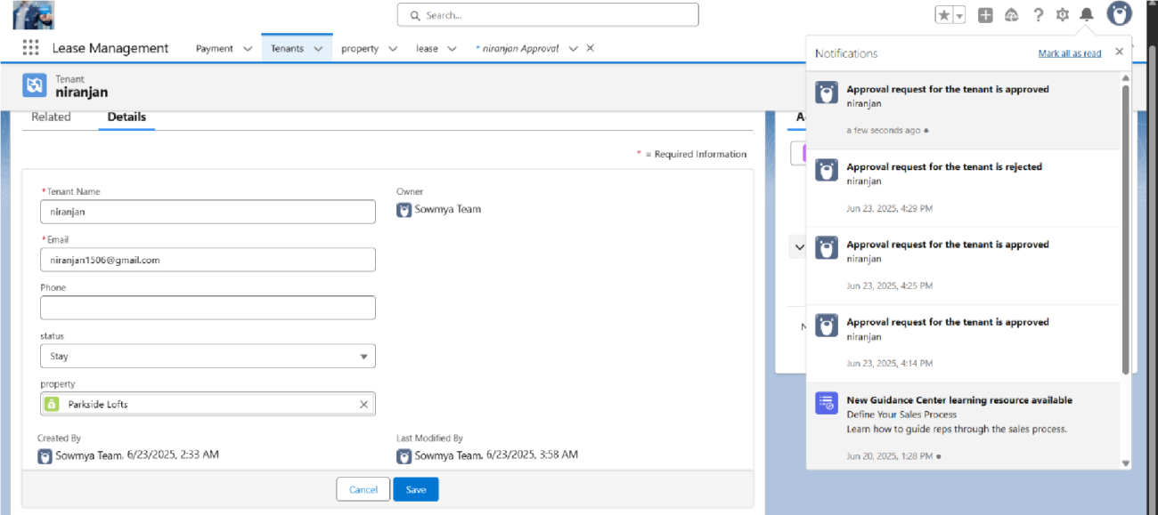

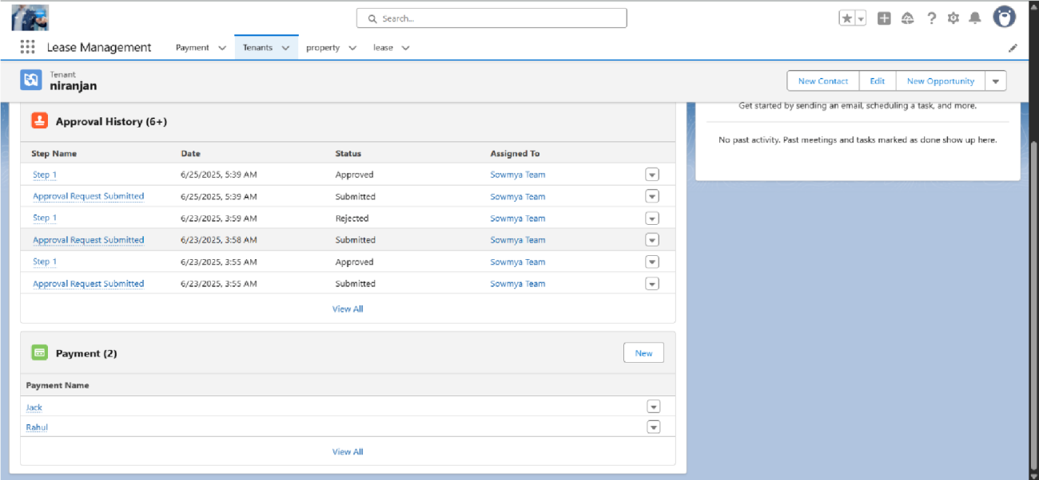

# RESULTS

## Output Screenshots

* + - Tabs for Property, Tenant, Lease, Payment

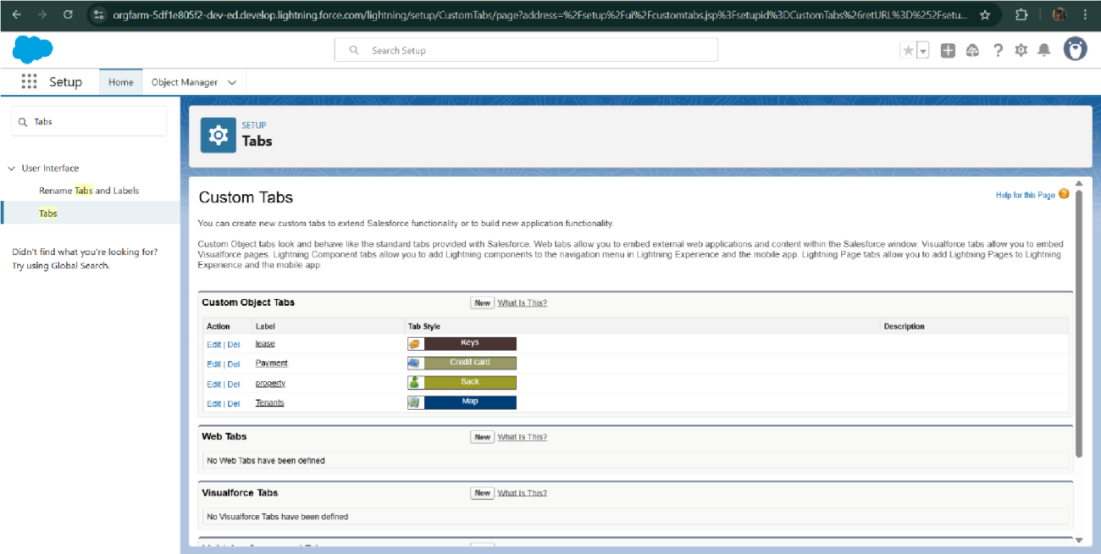

* + - Email alerts

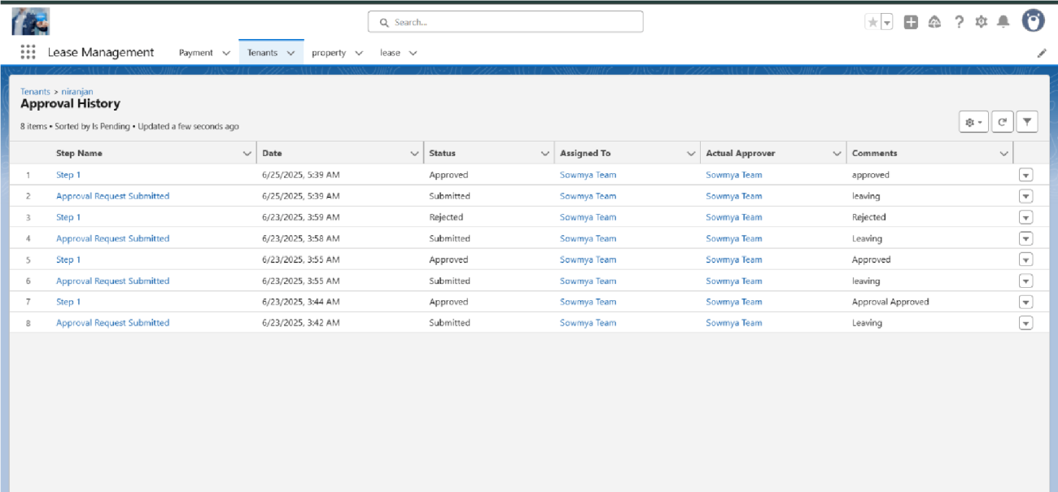

* + - Request for approve the leave

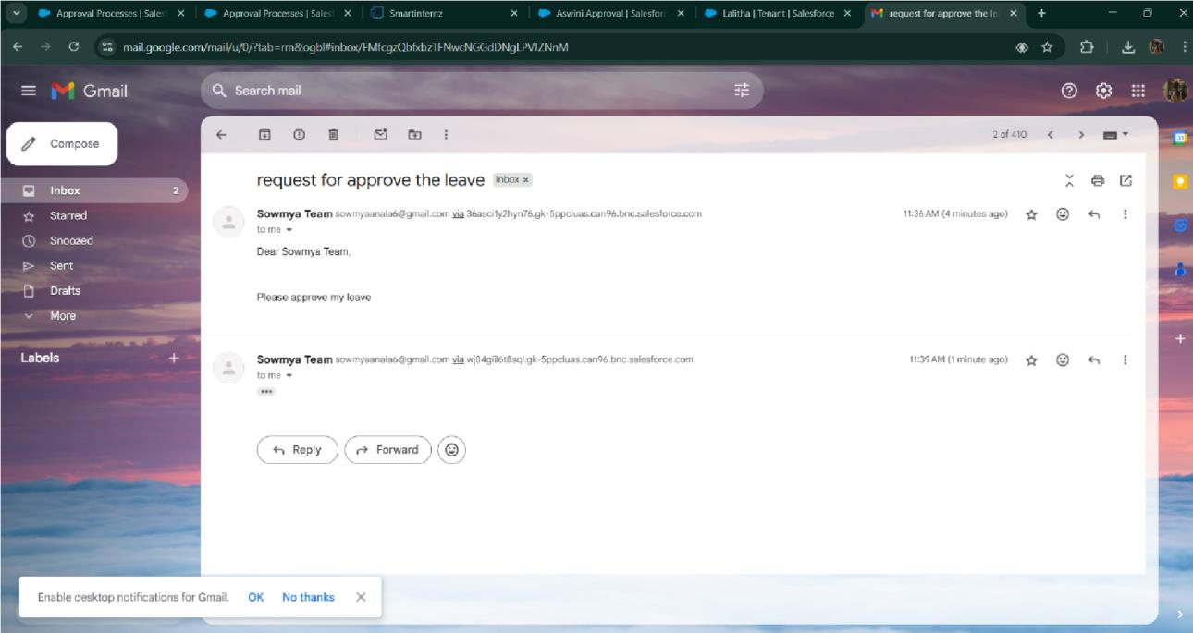

* + - Leave approved

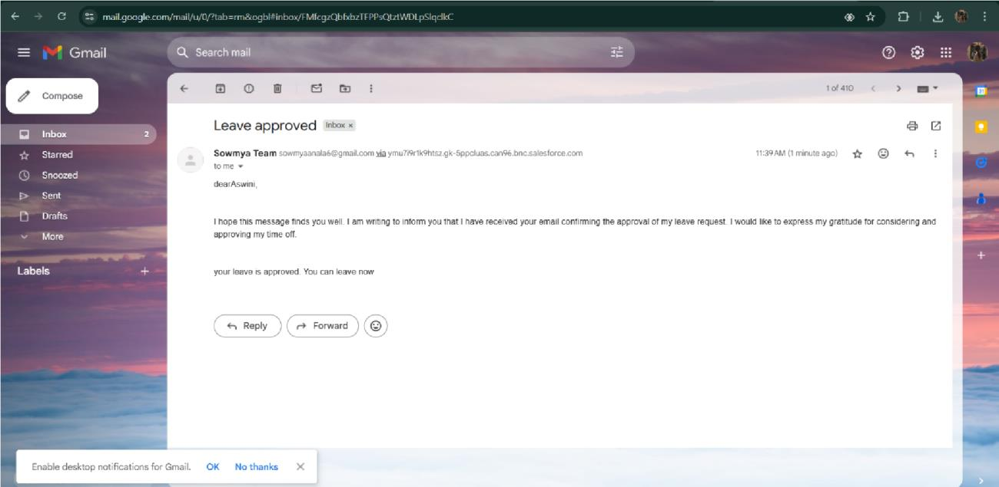

* + - Leave rejected

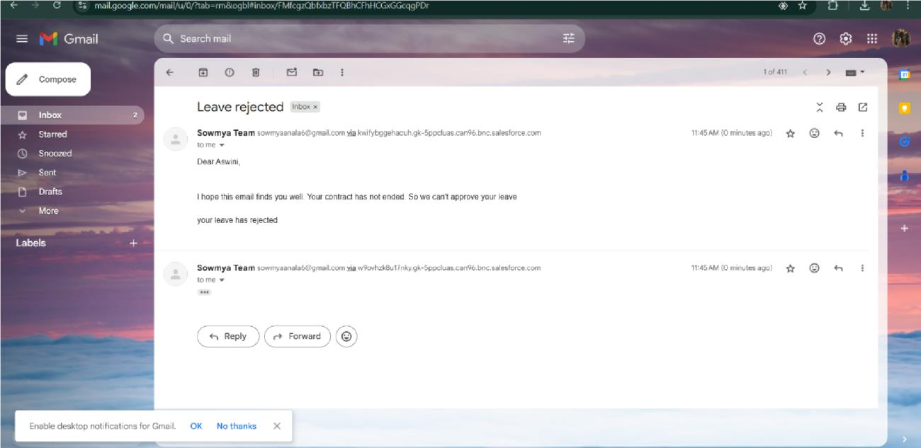

* + - Flow runs

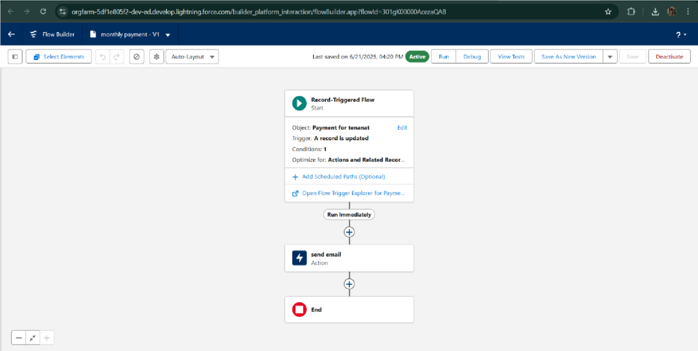

* + - Trigger error messages

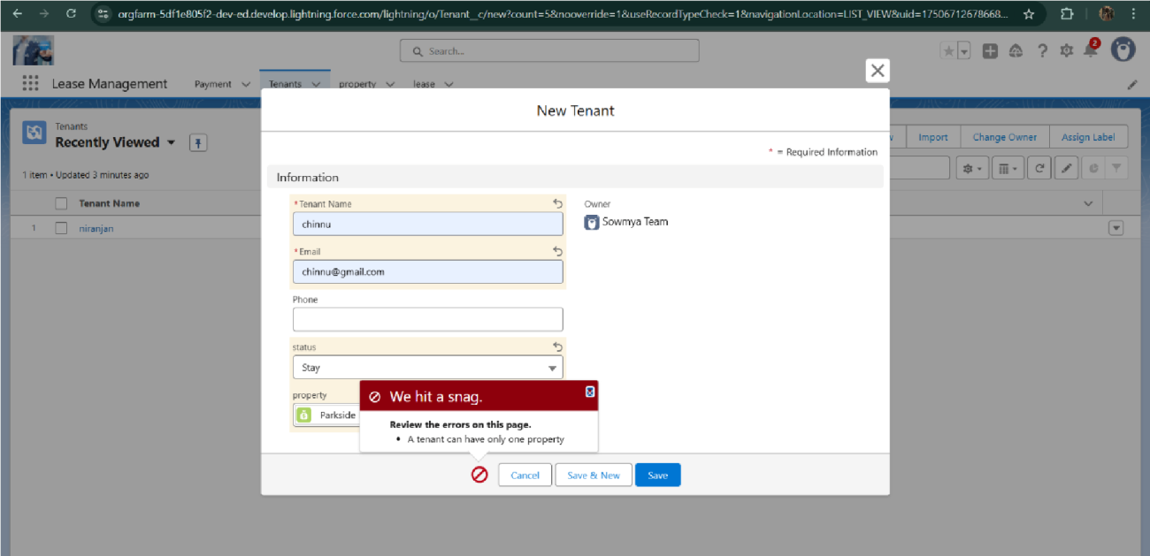

* + - Approval process notifications

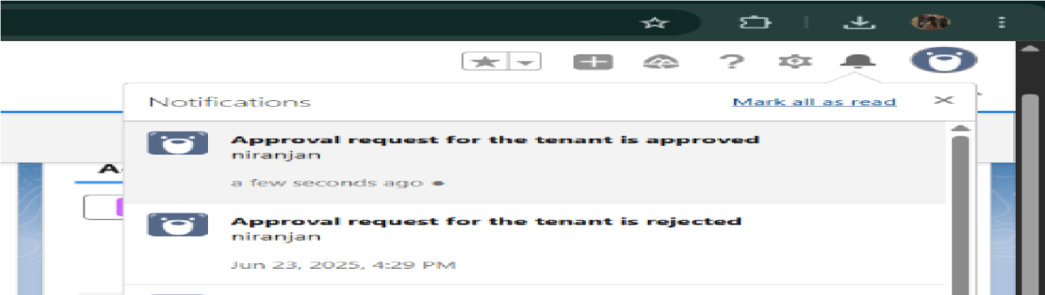

# ADVANTAGES & DISADVANTAGES

### Advantages:

1. **Centralized lease data**

All lease agreements, documents, and tenant information are stored in one system, improving organization and accessibility.

### Automated lease tracking

System-generated reminders for lease renewals, rent due dates, and compliance deadlines reduce missed tasks and penalties.

### Improved reporting and analytics

Real-time dashboards and reports provide insights into occupancy, lease expirations, and revenue, supporting better decision-making.

### Enhanced tenant communication

Automated emails and notifications streamline communication with tenants about payments, renewals, or maintenance updates.

### Audit readiness and compliance

Accurate records and change tracking help ensure compliance with lease accounting standards and audit requirements.

### Disadvantages:

1. **Initial setup complexity**

Implementing a lease management system can be time-consuming, requiring detailed data migration and configuration.

### User training required

Property managers and staff may need training to fully understand and use the system effectively.

### High implementation costs

Custom development, integration, and licensing fees can be expensive, especially for smaller firms.

### Dependence on digital access

Lease data is typically cloud-based, so system access requires internet connectivity and appropriate user permissions.

### Data security concerns

Storing sensitive lease and financial data digitally introduces the risk of unauthorized access or data breaches if not properly secured.

# CONCLUSION

The Lease Management System successfully streamlines the operations of leasing through a structured, automated Salesforce application. It improves efficiency, communication, and data accuracy for both admins and tenants.

# FUTURE SCOPE

### Future Scope of Lease Management System

1. **Integration with Online Payment Gateways**

Integrating secure online payment gateways (like Stripe, Razorpay, or PayPal) will allow tenants to pay rent, deposits, and other charges directly through the system. This ensures faster transactions, automated receipts, and real-time payment tracking—reducing manual reconciliation for finance teams.

### Visual Dashboards for Better Insights

Advanced dashboards using tools like Salesforce Reports or third-party analytics platforms can provide real-time insights into lease status, occupancy rates, rent collection, pending renewals, and more. These visualizations help property managers make data-driven decisions and forecast trends effectively.

### SMS Notification Features

Alongside emails, SMS alerts can notify tenants and staff about payment due dates, lease renewals, maintenance schedules, or compliance reminders. SMS communication ensures broader reach and immediate attention, especially when tenants are offline or prefer mobile updates.

### Role-Based Access and Analytics

Implementing detailed role-based permissions allows specific users (e.g., admin, property manager, tenant) to access only relevant features and data. Coupling this with role- specific analytics helps each user view KPIs tailored to their responsibilities, improving operational efficiency and security**.**

### Mobile App Support

A dedicated mobile app or mobile-responsive interface can empower tenants and managers to manage leases, payments, documents, and communications on the go. This improves accessibility and user engagement.

### AI-Powered Predictive Maintenance

Future versions could use AI to analyse maintenance patterns and predict when certain property assets (like HVAC or plumbing systems) may require servicing—helping reduce downtime and costs.

### E-signature and Document Automation

Integration with e-signature platforms (e.g., DocuSign, Adobe Sign) will allow digital signing of lease agreements and auto-generation of documents, streamlining onboarding and renewals**.**

### Compliance and Legal Tracking

Future features could include automated compliance tracking based on local real estate laws, lease accounting standards (like IFRS 16), and tax implications—minimizing legal risks**.**

### IoT Integration for Smart Leasing

Long-term, the system can integrate with IoT devices (e.g., smart locks, energy meters) for automated check-ins/outs, usage-based billing, and enhanced security or environmental monitoring**.**

### Multi-property and Franchise Support

As property portfolios grow, the system can evolve to support multiple properties across regions, including different currencies, tax rules, and regulatory compliance—making it suitable for franchises or large real estate chains**.**

# APPENDIX

* **Source Code:** Provided in Apex Classes and Triggers

**Test.apxt:**

trigger test on Tenant c (before insert) { if (trigger.isInsert && trigger.isBefore){ testHandler.preventInsert(trigger.new);

}

}

**testHandler.apxc:**

public class testHandler { public static void preventInsert(List<

Tenant c> newlist)

{ Set<Id> existingPropertyIds

= new Set<Id>()

for (Tenant c existingTenant : [SELECT Id, Property c FROM Tenant c WHERE Property c != null]) {

existingPropertyIds.add(existingTenant.Property c;

} for (Tenant c newTenant :

newlist) {

if (newTenant.Property c != null && existingPropertyIds.contains(newTenant.Property c)) { newTenant.addError('A

tenant can have only one property');

}

}

}

}

**MothlyEmailScheduler.apxc:**

global class MonthlyEmailScheduler implements Schedulable { global void execute(SchedulableContext sc) { Integer

currentDay = Date.today().day(); if (currentDay == 1) { sendMonthlyEmails();

}

} public static void sendMonthlyEmails() { List<Tenant c>

tenants = [SELECT Id, Email c FROM Tenant c]; for (Tenant c tenant :

tenants) {

String recipientEmail = tenant.Email c;

String emailContent = 'I trust this email finds you well. I am writing to remind you that the monthly rent is due Your timely payment ensures the smooth functioning of our rental arrangement and helps maintain a positive living environment for all.';

String emailSubject = 'Reminder: Monthly Rent Payment Due'; Messaging.SingleEmailMessage email = new Messaging.SingleEmailMessage(); email.setToAddresses(new String[]{recipientEmail}); email.setSubject(emailSubject); email.setPlainTextBody(emailContent);

Messaging.sendEmail(new Messaging.SingleEmailMessage[]{email});

}

}

}